Education Domain

**https://dju.b66.myftpupload.com/**

**U. Mohan Srinivas**

**Faculty**

**Educator Login for https://smartinternz.com/Student/badge_workspace/8072**

**Educator Login with email ID: mohan.srinivas@gmail.com**

**Course Join with email ID: umohansrinivas@gmail.com**

**1. INTRODUCTION**

1.1 Overview

This WordPress website is based on the corporate domain. This website was intended to be made for a builder's company. This website contains all the information about the company as well as some extra additions. The website is completely made using WordPress website builder Elementor and a few other plugins. Also the website would be the first ever one to be made by myself so it is also a learning curve as well.

1.2 Purpose

The purpose of making this website was because the client wanted a way to expand their reach to their customers. Making a website in today's day and age is a necessity or else your company will find it difficult to survive. The purpose of this was also to learn something new as this was the first time ever using WordPress.

The main goals of this project are:

1. Understanding the corporate industry for builders.
2. Learning from other websites and deciding on a design to go with.
3. Learn about WordPress and it's plugins.
4. Explore what features can be added to the website to make it stand out from the

rest of the crowd.

**2. LITERATURE SURVEY**

**2.1 Existing problem**

User Interface Design and User experience are two tasks that are implemented earlier manually in several ways. In this process more technical knowledge is required to understand the design steps in coding. It is also tedious to implement with the use regular text editors. take

**2.2 Proposed solution**

WordPress is another solution for UI design and development of web pages. First the software environment components Apache a webserver, PHP for Server side Script programming Language, MySQL a Database that is managed visually with phpMyAdmin browser based tool are installed. Later WordPress installed in it.

GoDaddy.com is provider for hosting of the website in a test domain. In order to host the website on GoDaddy need to create the GoDaddy Account.

**3. THEORITICAL ANALYSIS**

**3.1 Block diagram**

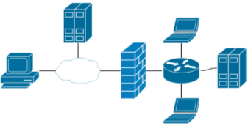

This block diagram shows the basic interaction of the website with its constituent parts.

The website can be accessed via any device be it a laptop, computer or mobile. The site is connected to a server that is used for hosting. Request coming in from the device travel through the cloud and to the server where a response is sent back. Also a firewall exists in order to make sure that the data sent is not dangerous.

**3.2 Hardware / Software designing**

Any Desktop / Laptop with OS either windows or Linux running and web browser is required for minimum initial stage of doing work.

The hardware of mylatop is:

Processor: Intel Core i3

500GB Hard Disk for Storage

RAM: 8GB

Keyboard and Mouse

The Software used in this project:

Windows 10 Pro OS

Bitnami Wordpress - Apache Webserver, Wordpress with necessary Plugins, and Themes, MySQL Softwares and browser Google Chrome / Internet Explorer, Mozilla Forefox etc

To start your Project need to install few pre-requisites listed as follows:

1. XAMPP Server
2. WordPress

*XAMPP Server*

XAMPP is a free and open-source cross-platform web server solution stack package developed by Apache Friends, consisting mainly of the Apache HTTP Server, MariaDB database, and interpreters for scripts written in the PHP and Perl programming languages.

Download and Install Xampp Server Locally

To work on XAMPP Server Locally Need to download and install the same using the reference link given in the reference section

XAMPP is an easy to install Apache distribution containing MariaDB, PHP and Perl.

https://www.apachefriends.org/index.html

*WordPress*

WordPress is a free and open-source content management system written in PHP and paired with a MySQL or MariaDB database. Features include a plugin architecture and a template system, referred to within WordPress as Themes.

Download WordPress

To work on project, you need to download the WordPress Locally Need to Install the same using the reference link given in the reference section

Download WordPress today, and get started on creating your website with one of the most powerful, popular, and customizable platforms in the world.

https://wordpress.org/download/

**4. EXPERIMENTAL INVESTIGATIONS**

While making the website there were many things that were tried and tested. For example, the first thing I did was explore the many templates wordpress had to offer. Testing it out with the structure I had in place to see if it matches.

Then also wordpress offers several plugins. I had wanted to create a form and elementor the builder I was using required you to be a pro member hence I downloaded a few form plugins and tested them out. Out of all of them I did find one really good one called ninja forms. It has all the basic features I needed to add without complicating anything.

Then for the website I initially start with a minimal design where there would be less writing and more pictures but later on using that it did not suit the website too well so I decided to go with a balance between minimal and maximal. The deign made sure to not overcrowd the website so as to not make the user feel overwhelmed but have enough information that the end user can clearly understand what this website is all about.

**5. FLOWCHART**

|  |  |  |
| --- | --- | --- |
| Home Page | + | Contact Us Page |

**6. RESULT**

By making this website I have learned alot from wordpress. From accessing many templates and learning to customize them to my standards. Also researching about other plugins made me learn more about wordpress and the many different directions one can take while making their websites. Wordpress is a really great tool for someone with no experience in coding to make and it's an even better tool for someone who knows how to manipulate code.

The overall look of the website was quiet clean and I have maintained a standard pattern keeping things unifrom in all the pages of the site. This was a great learning expereince.

**7. ADVANTAGES & DISADVANTAGES**

**ADVANTAGES:**

**1. EASY TO USE**

The most vibrant feature of WordPress is its ease. Anyone can become expert while playing with the software because it has an intuitive interface. It comes with an inbuilt dashboard where users can add new pages, posts, or categories, change themes and settings, and much more. The open-source platform comes free which makes it a cost-effective option.

**2. RESPONSIVE DESIGN**

As mobile has become the best place to fetch traffic for business websites, they need to be responsive to reach the potential buyers on the mobile channel. WordPress offers a responsive design which ensures that your website runs seamlessly on different devices, without having to put in extra effort for developing separate websites to run on them.

**3. PLUGINS FOR CUSTOMIZATION**

Plugins are the backbone of this platform. By making use of plugins, users can customize the site and add the desired features and functionalities to it. All that is needed to be done for adding a new feature to the site is to install a plugin. And amazingly, there is a large number available and most of them are free of cost or reasonably priced.

**4. FLEXIBILITY**

WordPress is an open-source CMS that bundles amazing flexibility as it can be used for creating a variety of websites. You can use it for creating personal blog, a full-fledged business website, or an e-commerce store. Additionally, you get the choice to use any of the existing designs or tailor a new one.

**5. MINIMAL CODING**

With WordPress, the coding needs are reduced to the minimum as the CMS comes with an array of user-friendly tools which enable you to do a lot without any hard work. Managing content, creating drafts, revising posts, inserting media, and planning the publications, all can be done easily with minimal coding.

**DISADVANTAGES**:

1. Pro Mode: there are many useful features wordpress has, but some features that would have really helped make things easier for me but it was required that you use the pro version.
2. Too many plugins: I has read that using too many plugins may slow down the preformance of the site. But then to access some features that were on the pro version of other plugins I had to install them. This resulted in alot of plugins. Eventually I had to compromise by removing some plugins for performance.

**8. APPLICATIONS**

Wordpress has a wide range of applications. It can be used in almost every industry if

not all of them.

1. The first application is to develop a classified site for business or organization purpose. I have made my website based on this application.
2. You can also use wordpress to develop a real estate and property listing web area.
3. Setting up portfolios is among the major highlights of wordpress, here the author could build flexible and dynamic portfolios.
4. With the variety of social media plugins, WordPress stands as a social hub. Feeds from Twitter, Facebook, and other media can be precisely embedded into the page and will routinely bring up to date as soon as the user posts to the different social profiles.
5. You can also use it to build your own blog site. Wordpressis really useful for those who want to reach out to a crowd with their thoughts and opinions. Hence blog sites are a really great application and are very easy to setup on wordpress.

**9. CONCLUSION**

By using WordPress, it is more easy to maintain websites in several points – adding content to web pages, creating new pages, selecting themes and appearance of the pages and many more.

Here the website is designed for an academic domain specific to a department in an engineering college with sample data.

By using this WordPress with no code or less code it is possible to design web pages of websites by adding WordPress Plugins, Themes.

The most critical operations upload, backup and restore after design and development of the webpages for specific domain can be performed effortlessly with WordPress supported host providers like godaddy.com. Eventually the Host Provider GoDaddy.com is also providing support of cPanel or Plesk Control Panel to do deploy and maintain the websites.

**10. FUTURE SCOPE**

In this project the information is displayed from every page in the website is basically built as static data. Also this website is restricted to department with limited information. This can be extended to college level or university level based on the type of institution and data that needed to be maintained in website based on NIRF, NAAC, NBA & ISO.

Even it can be extended in the design of every page with more interactive and database driven based information so as to become dynamic in web pages.

**11. BIBILOGRAPHY**

[1]. Software Link to Download and Install XAMPP Server Locally

https://www.apachefriends.org/index.html

[2]. Software Link to Download WordPress

https://wordpress.org/download/

[3]. ***Understanding Websites*** Free Program Learning from Godaddy Academy

https://godaddyacademy.com/

[4]. ***Working with Wordpress*** Promo based Free Program Learning from Godaddy Academy

https://godaddyacademy.com/

[5].How to Install XAMPP and WordPress Locally on Windows PC

https://themeisle.com/blog/install-xampp-and-wordpress-locally/

[6]. How to Create a Local WordPress Site Using XAMPP? https://www.wpbeginner.com/wp-tutorials/how-to-create-a-local-wordpress-site-using-

xampp/

[7]. How to Make a WordPress Website: Step-by-Step Guide for Beginners?

https://themeisle.com/blog/how-to-make-a-website/

[8]. A Complete WordPress Tutorial Series In This Tutorial, We will learn How to install WordPress on localhost with xampp on Window. Full Tutorial Step By Step Join Telegram Channel https://t.me/codeanddesign

[9]. Learn WordPress Full Series https://goo.gl/Tj5kvM

UI Design Tutorials https://goo.gl/P41Ugo

https://www.facebook.com/codeanddesignindia

https://twitter.com/codeanddesignin

https://www.instagram.com/code_and_design_india

https://twitter.com/Ravikantjhavfx

https://www.instagram.com/vfxravi

https://www.linkedin.com/in/ravikant-jha-07a6a779?trk=nav_responsive_tab_profile

[10]. https://www.youtube.com/watch?v=Gknrbr2Ju8k

**APPENDIX**

**Screenshots of the Website**

The is a Test based design of Website that consists of Two Pages only



1. Home Page

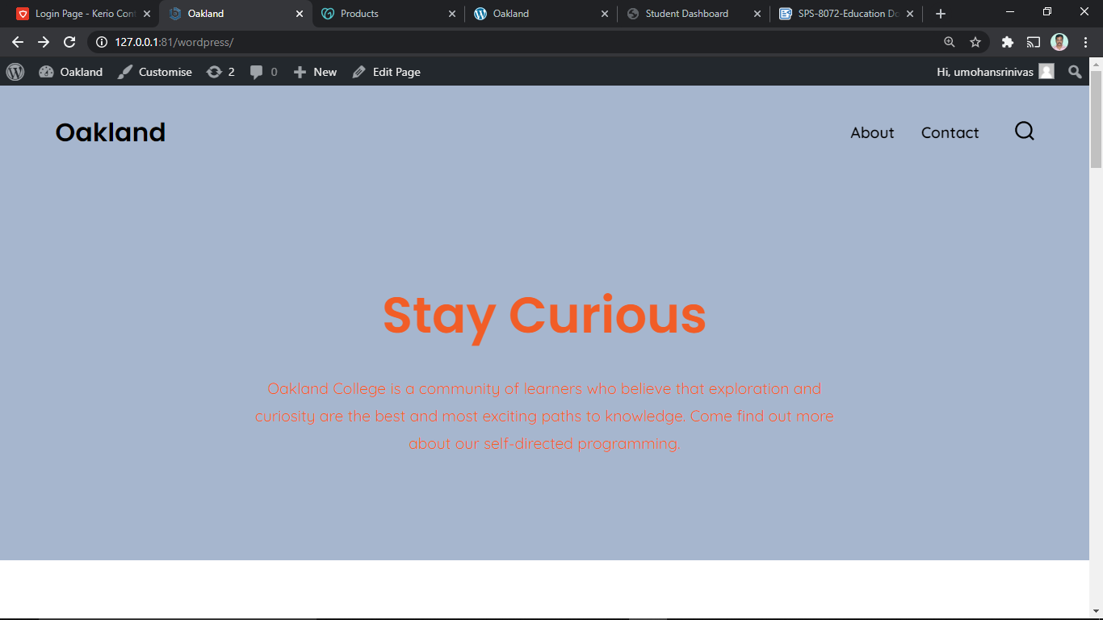

2. Contact Us Page

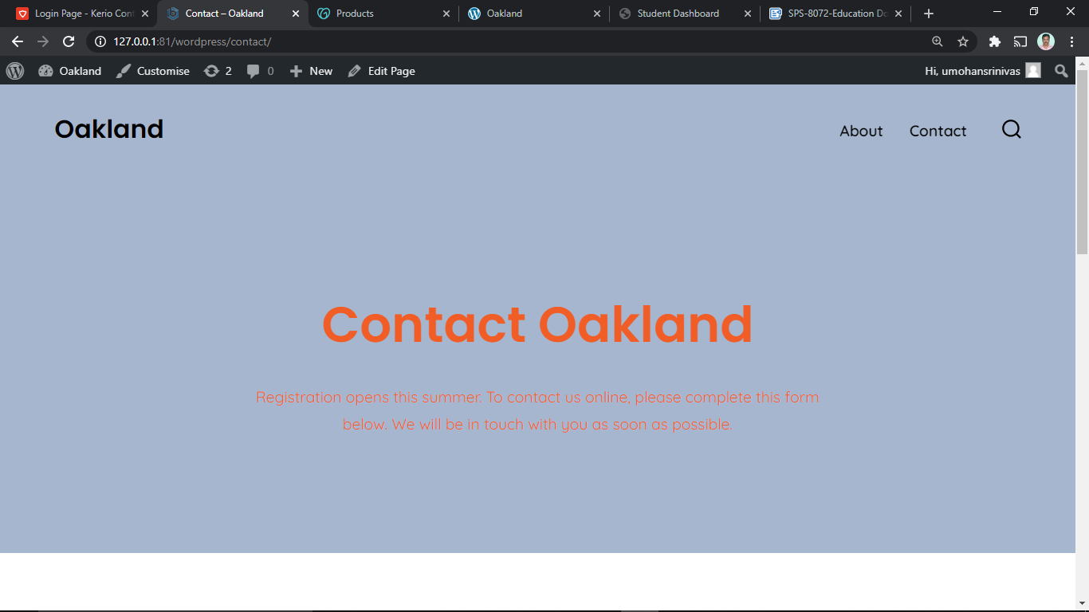

**A. Source code**

Attached to Git-repo public link url:

For Example :

Website for Schools

Website for College

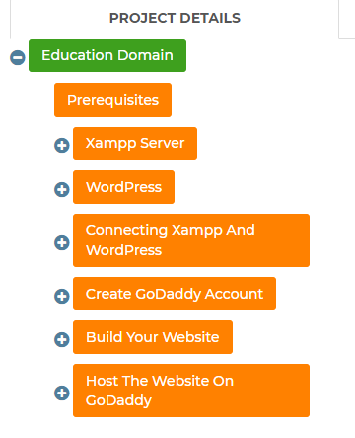

**Step 1:** Download and install XAMPP on your computer

Goto the URL: https://www.apachefriends.org/index.html

Select XAMPP for Windows and download file URL

https://www.apachefriends.org/xampp-files/8.0.1/xampp-windows-x64-8.0.1-0-VS16-installer.exe

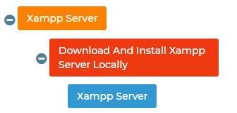



Once the download finishes, run the file you downloaded to launch the XAMPP installer.

If you’re running antivirus software, you might get a warning.

Just click **Yes** to continue.

Depending on your Windows configuration, you might also get a prompt about User Account Control (**UAC**). Just continue through that prompt as well. Once you get through all of the prompts, you should see the standard installer screen:

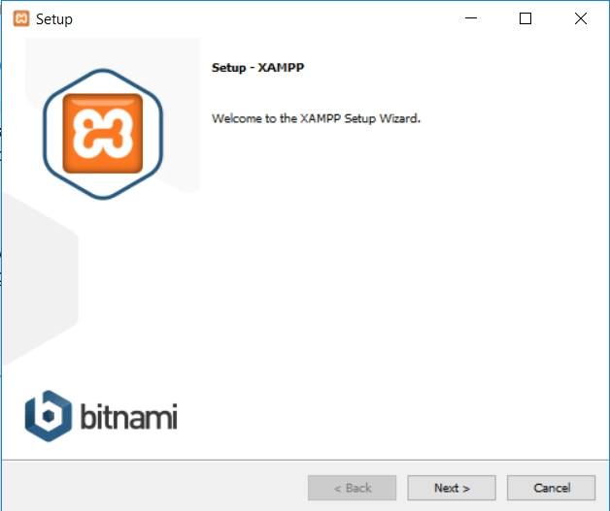

Just click Next to continue.

On the next screen, you can choose which components to install. **To install XAMPP and WordPress,** you do not need all of the components. In addition to the required components, all you need are:

* MySQL
* PHPMyAdmin

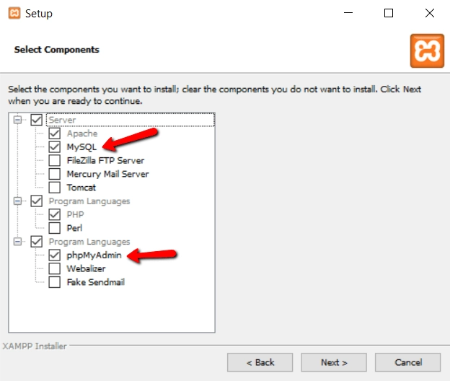

Again, this is all that’s needed to install WordPress locally. Uncheck everything else and click Next.

You can now select which folder to install XAMPP in. I always leave it as the default:

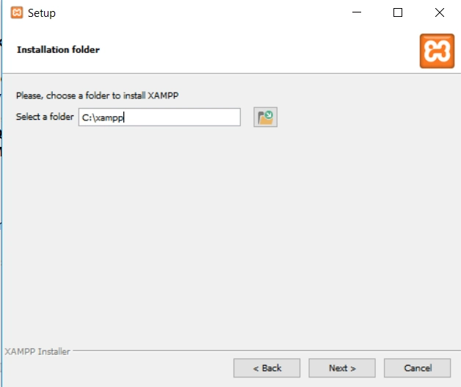

On the next screen, you’ll get a prompt asking you to install Bitnami for XAMPP. You do not need this to install XAMPP and WordPress, so just **uncheck the box**:

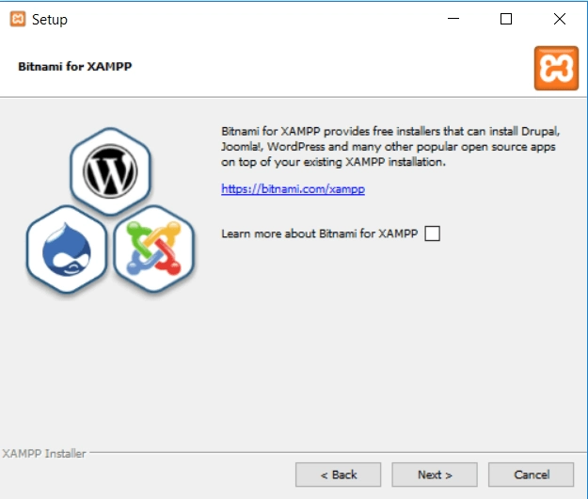

Once you click **Next**, you’re ready to run the install:

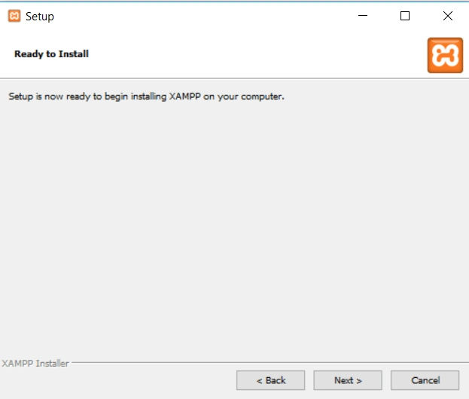

The install process might take a few minutes:

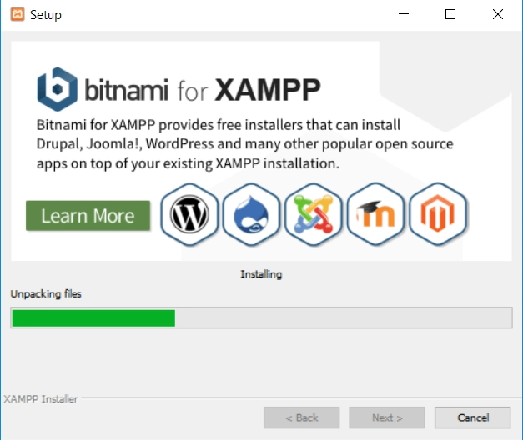

Once it finishes, you can launch the control panel to start working with XAMPP:

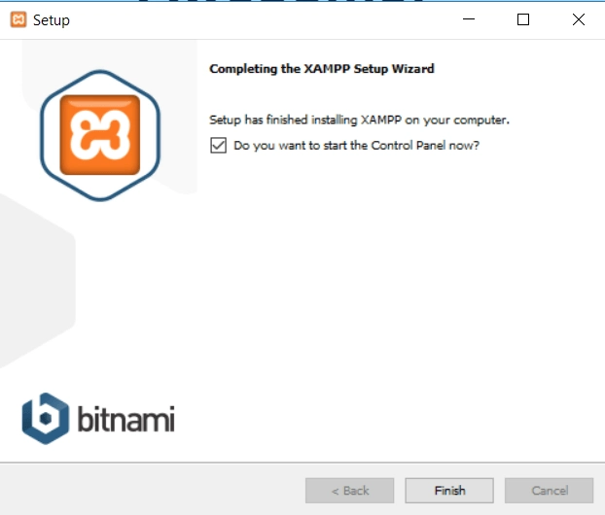

**Step 2**: Start the modules and test your server

To install XAMPP and WordPress properly, you’ll need to run two modules:

1. Apache
2. MySQL

You can start both modules from the XAMPP control panel:

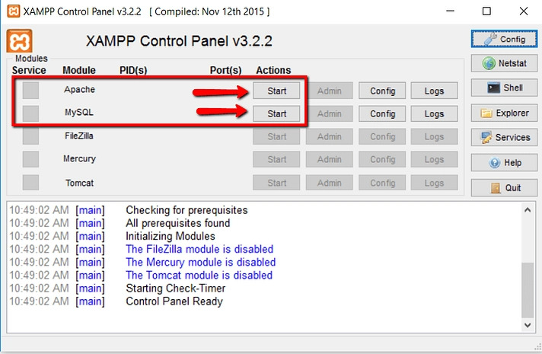

Once you launch them, you should see their status turn to green:

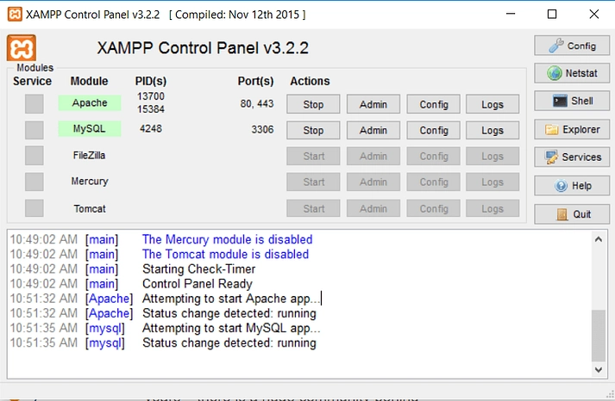

And now you should be able to test that your local server is working by going to http://localhost/ in your web browser of choice:

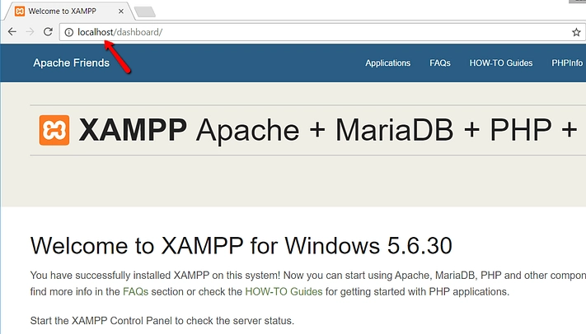

If all went well, you now have a functioning XAMPP server on your Windows PC! But now it’s time to **install** XAMPP and **WordPress**. So here’s how to get a WordPress site up and running on XAMPP.

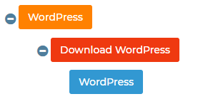

**Step** **3:** Add the WordPress files

Goto URL: **https://wordpress.org/** and download the latest version of WordPress.

file URL is **https://wordpress.org/latest.zip**

Then, in Windows, navigate to the folder where you installed XAMPP. For me, that’s C://xampp. It should be something similar for you. Then, in that folder, find the **htdocs** subfolder:

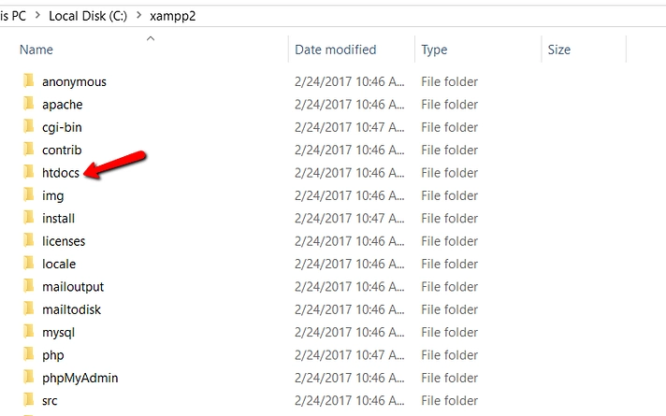

**In htdocs, create a new folder for your test site**. This folder name will become the sub-name used to access your site. For example, if you make the folder testsite, you’ll access your site by going to **http://localhost/testsite**.

Once you create the folder, **extract the WordPress .zip file** you downloaded from wordpress.org into it:

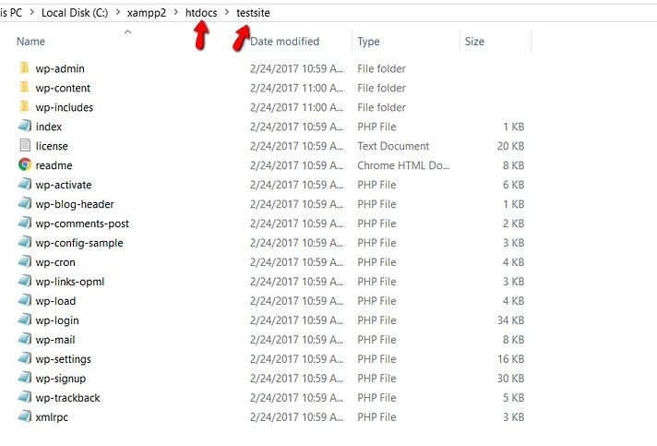

**Step 4:** Create a database for WordPress

Next, you need to create a MySQL database for your WordPress install. To do that, **launch PHPMyAdmin from your XAMPP control panel:**

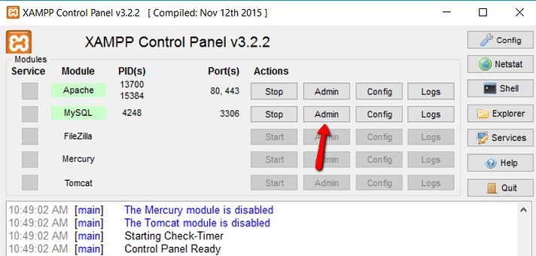

Then click on Databases at the top:

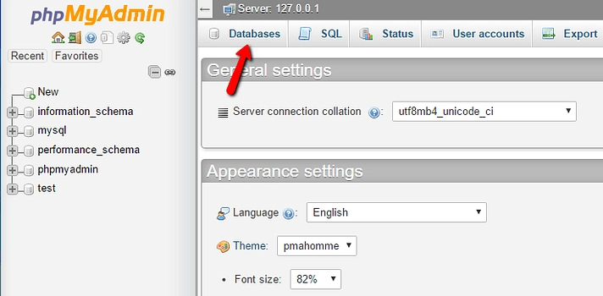

And enter a name for your database and click **Create**. Your **name can be anything** – just remember it because you’ll need it for the next step:

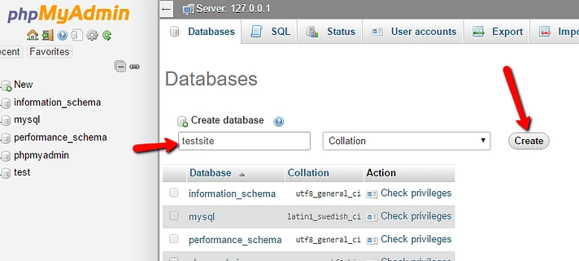

**Step 5: I**nstall WordPress locally via the on-screen installer

When you visit your test site, you should see the normal WordPress installer. Remember, your test site is just **http://localhost/FOLDERNAME**:

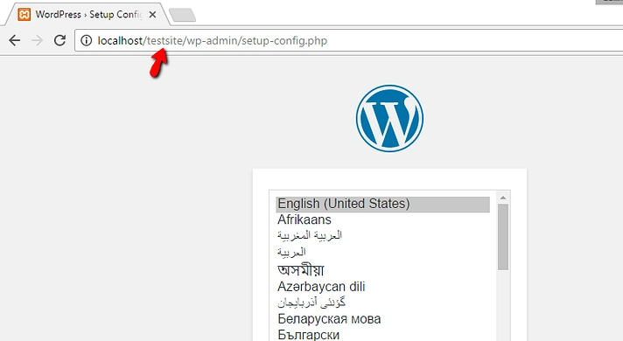

The only step where this process will differ from a normal install is the database details. When you get to the database details, enter them like this:

1. **Database Name** = Name of the database you created in PHPMyAdmin
2. **Username** = “root”
3. **Password** = leave blank

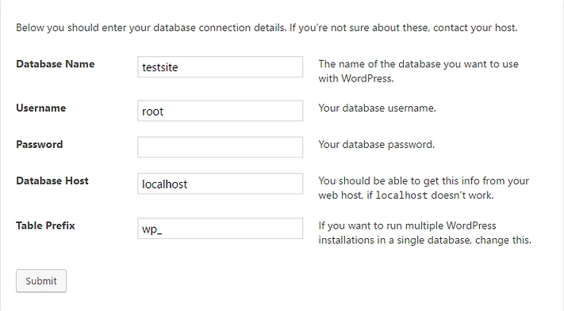

Then finish the rest of the WordPress install process like normal.

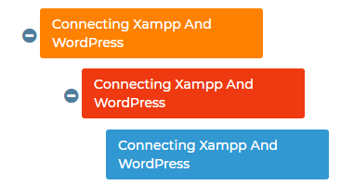

With all the above steps now Connecting XAMPP and Wordpress is completed.

